SIMATS ENGINEERING (SAVEETHA SCHOOL OF ENGINEERING)
Department of Computer Science and Engineering
ASSESSMENT TOOL 2 – EXPERIMENTATION

Course Code: | ITA03 | Course Title: | Mobile computing
CO Assessed: | CO2 | Assessment: | Assessment Tool 2 – EXPERIMENTATION
Weightage: | 30 % of CIA | Total Marks: | 20 marks
CO2 Statement: | Compare mobile communication technologies, including multiple access techniques and network evolution, based on performance and applications.
Student Name: | Lalith Kumar | Reg. No.: | 192421321
Section / Batch: | B.Tech [IT] / 2024 | Date: | 04/08/2026

Code of Conduct

I ___________Lalith Kumar (192421321)___________ (Name / Reg. No) certify that this submission is my original work and that I have adhered to the guidelines specified for this assessment. I understand that any violation of academic integrity rules will result in disciplinary action.
Signature of the Student: ____Lalith Kumar_______

Instructions
- This test contains ONE question.
- Duration: 30 minutes.

Faculty In-charge | Course Coordinator | Head of Department
Signature: _______________ | Signature: _______________ | Signature: _______________
Date: ___________________ | Date: ___________________ | Date: ___________________

Annexure A - QUESTIONS

Figma-Based Mobile IP Communication Workflow Analysis (BL4 – Analyze)
Design an interactive Figma prototype illustrating the complete workflow of Mobile IP communication when a Mobile Node moves from its Home Network to a Foreign Network. Your design should include the Home Agent (HA), Foreign Agent (FA), Correspondent Node (CN), Care-of Address (CoA), Registration Process, and Packet Tunneling.
Analyze the communication process by identifying:
- The purpose of each network component.
- Points where packet delay or packet loss may occur.
- The effect of node mobility on communication performance.
- Possible improvements to reduce latency.
Deliverables:
- Figma (.fig) design
- GitHub repository containing exported images/PDF and documentation (README).
https://www.figma.com/make/ud4jfKeoFqDTH5nlboAQbg/Mobile-IP-Communication-Workflow?code-node-id=0-9&p=f&t=fs1BbIBU0ratVpun-0&fullscreen=1
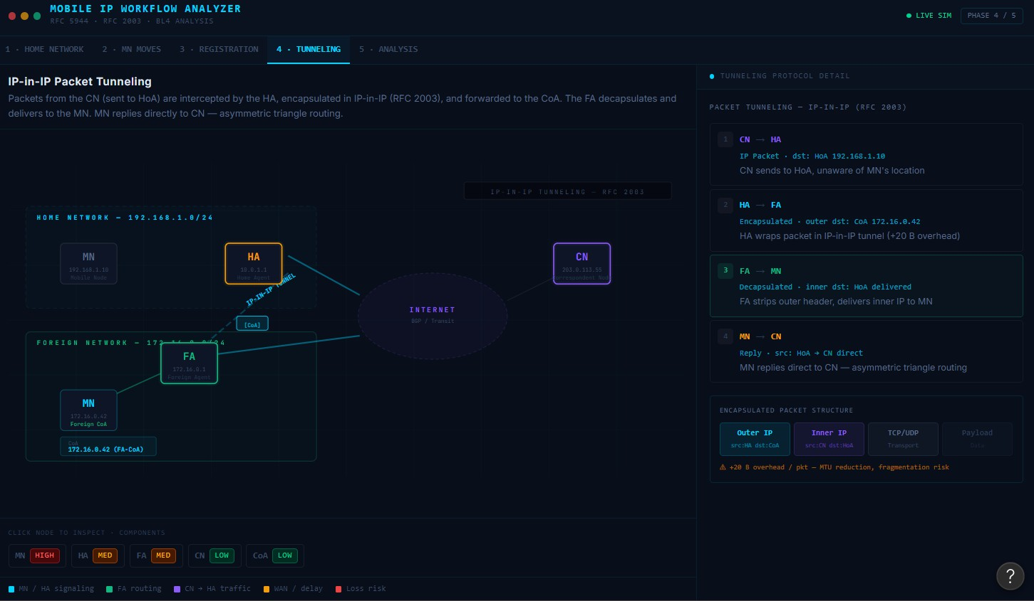

Comparative Network Architecture Design Using Figma (BL4 – Analyze)
Using Figma or draw.io, create a comparative architectural diagram showing both a Cellular Wireless Network and a Mobile Ad Hoc Network (MANET) operating in the same smart city environment.
Analyze the architectures by comparing:
- Infrastructure dependency.
- Routing mechanisms.
- Scalability.
- Fault tolerance.
- Mobility support.
- Suitable application scenarios.
Highlight the advantages and limitations of each architecture through annotations in your design.
Deliverables:
- Editable design file.
- GitHub repository with screenshots, comparison report, and design assets.
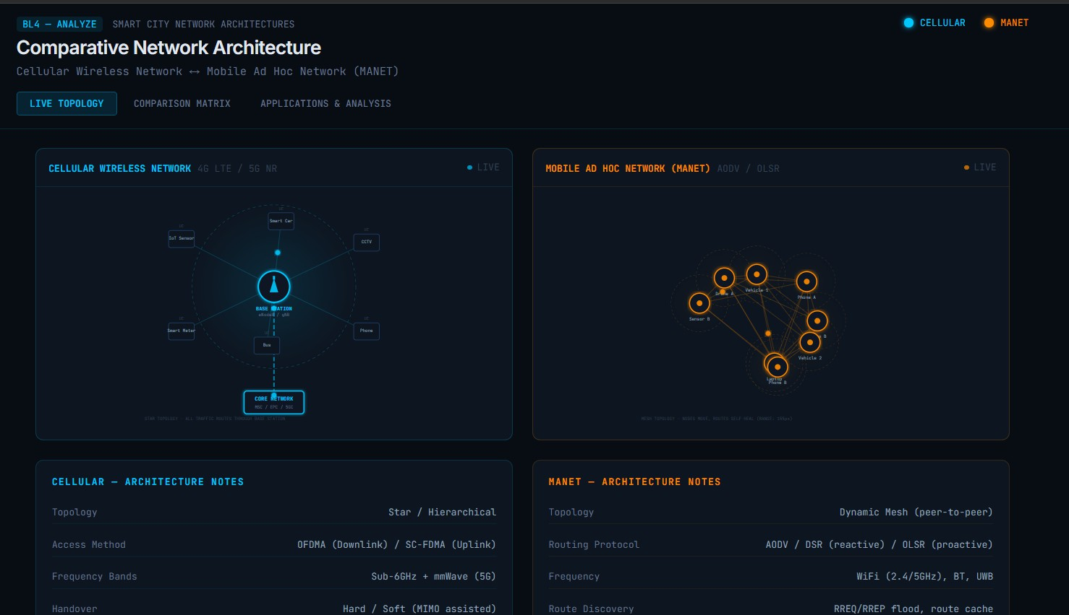
https://www.figma.com/make/CCYGtCadArKZFKe7vRSe1g/Comparative-Network-Architecture-Diagram?fullscreen=1&t=eOmH7LgGiugKGbQY-1&code-node-id=0-9

Routing Protocol Visualization and Analysis (BL4 – Analyze)
Develop an interactive visualization using Figma, Mermaid.js, D3.js, or any visualization framework illustrating the operation of one Proactive Routing Protocol and one Reactive Routing Protocol in a mobile wireless network.
Analyze:
- Route discovery process.
- Route maintenance mechanism.
- Routing overhead.
- Delay in establishing communication.
- Performance under high node mobility.
Include a comparative summary explaining which protocol performs better under different mobility conditions.
Deliverables:
- Source code/design files.
- GitHub repository with implementation, screenshots, and analysis report.
https://www.figma.com/make/4H40aXtmTFfMF4KYB6ieTq/Routing-Protocol-Visualization?code-node-id=0-9&p=f&t=xerUJm9Bh9xGPNbf-0&fullscreen=1
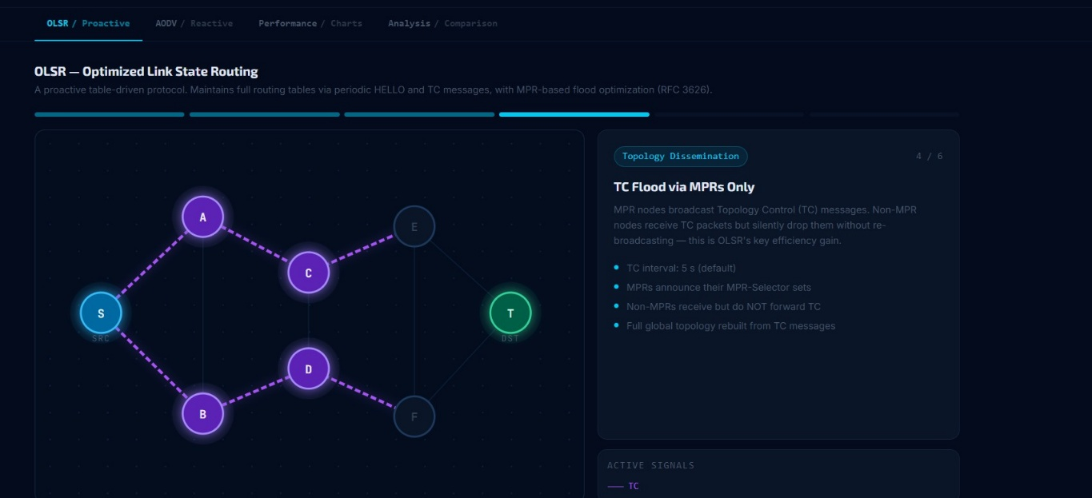

Mobile IP Application Design for Smart Healthcare (BL4 – Analyze)
Design a Smart Healthcare Mobile IP system using Figma that enables doctors, ambulances, hospitals, and patients to remain connected while moving across different wireless networks.
Analyze:
- How Mobile IP maintains uninterrupted communication.
- Challenges during handoff between networks.
- Security vulnerabilities during mobility.
- Possible design improvements to increase reliability.
Provide navigation between screens demonstrating different mobility scenarios.
Deliverables:
- Interactive prototype.
- GitHub repository containing design files, exported prototype, and documentation.
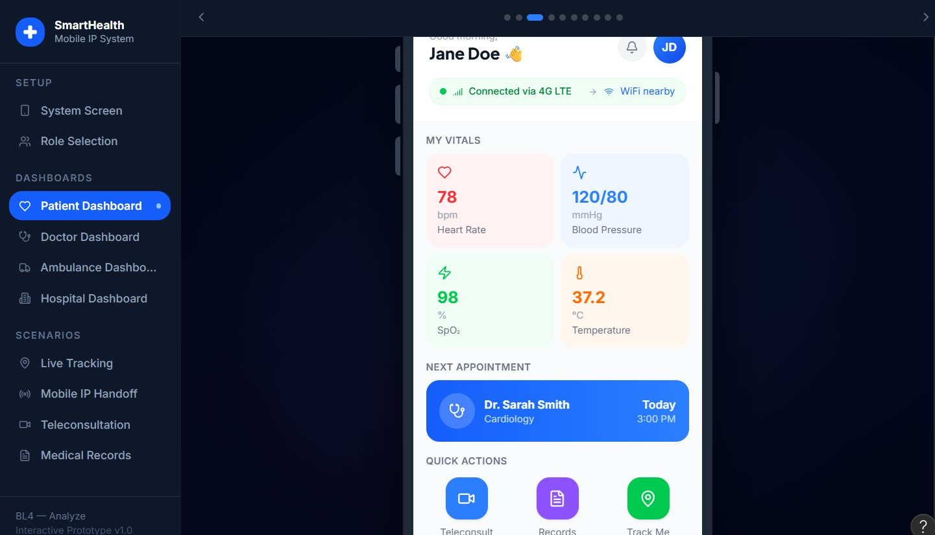
https://www.figma.com/make/0x4q4yX7OwKA6C1u4sqRFS/Smart-Healthcare-Mobile-IP-Design?code-node-id=0-9&p=f&t=cK6w1haCVqgFahWi-0&fullscreen=1

Wireless Network Decision Dashboard Using GitHub Project (BL4 – Analyze)
Create a web-based dashboard (using HTML/CSS/JavaScript, React, or another programming framework) or an interactive Figma dashboard that helps network engineers determine whether a given scenario should use Mobile IP, Cellular Networks, or Ad Hoc Networks.
The dashboard should analyze multiple parameters such as:
- Node mobility.
- Infrastructure availability.
- Network size.
- Routing complexity.
- Energy consumption.
- Reliability requirements.
The system should justify its recommendation based on the analyzed parameters.
Deliverables:
- Source code or Figma project.
- GitHub repository with complete code/design, README, screenshots, and analysis report.

https://www.figma.com/make/yJz9Tr5Bfg1SfBSgKqRbw9/Network-Decision-Dashboard?code-node-id=0-6&p=f&t=N2ruM4Othz0oeyIM-0&fullscreen=1
Criterion | Marks
Design Quality (Figma/Programming Tool) | 20
Technical Analysis (BL4) | 30
Correctness of Mobile Networking Concepts | 20
GitHub Repository Organization & Documentation | 15
Creativity and Visualization | 15
Total | 100 Marks
